Your voice is needed on National Injury Prevention Day 2023.
Join us taking part is as easy as 1, 2, 3.
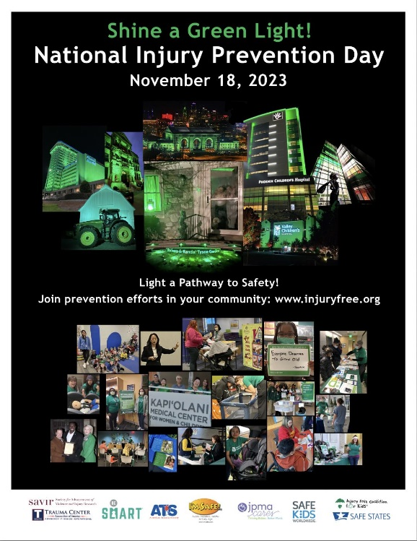

- Go to www.injuryfree.org
- Click on National Injury Prevention
Day in the Green Bar
- Click on Submit Event Information
and complete the Form
Tell us if you are:
  - Shining a green light
  - Getting a proclamation
  - Having a Community Program or Event
  - Having an internal Staff Education Event
  - Doing Research or Programming
  - Social Media or other Media

Please submit a separate form for each activity.

If you have questions, e-mail estelljohnson@sbcglobal.net or call 816-651-7777.

